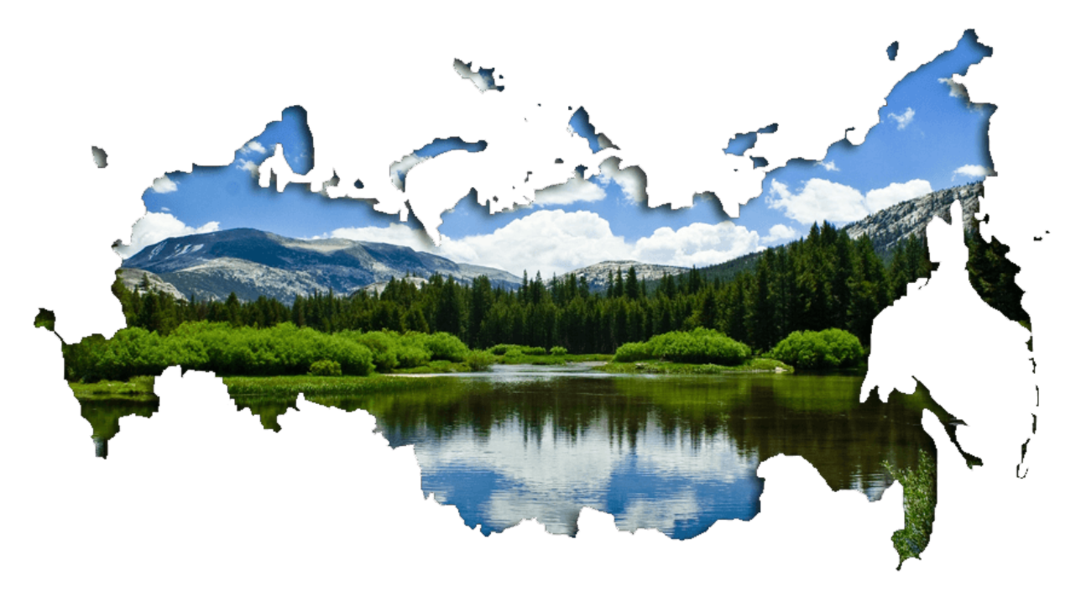

**5**

**Команда № 1**



**8**





**6**

**1**

https://phonoteka.org/uploads/posts/2021-05/1620250301_17-phonoteka_org-p-fon-malaya-rodina-18.png



**1**







**Команда № 2**

**1**

**5**



https://phonoteka.org/uploads/posts/2021-05/1620250301_17-phonoteka_org-p-fon-malaya-rodina-18.png

**8**



**6**





**1**



https://phonoteka.org/uploads/posts/2021-05/1620250301_17-phonoteka_org-p-fon-malaya-rodina-18.pnghttps://phonoteka.org/uploads/posts/2021-05/1620250301_17-phonoteka_org-p-fon-malaya-rodina-18.pnghttps://phonoteka.org/uploads/posts/2021-05/1620250301_17-phonoteka_org-p-fon-malaya-rodina-18.png

**5**

**8**

**6**

**1**

**1**

**8**

**6**

**1**

**1**

**5**

**Команда № 3**

**Команда № 4**